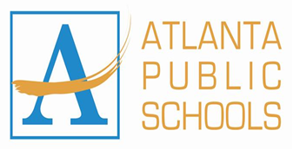.

**Humphries Elementary School**

3029 Humphries Dr SE

Atlanta, Georgia 30354

(404) 802-8750

**Lindsey Kilgore**

Gifted Teacher

Welcome Back!

Gifted & Talented Students and Their Parents:

Welcome back to a new year at Humphries Elementary. We are excited to have such a bright group of motivated students among our student body. This school year, the Gifted & Talented program at Humphries will be overseen by gifted coordinator Mrs. Mona Haygood and gifted-teacher Mrs. Lindsey Kilgore. Gifted students will be served every Monday, Tuesday, Thursday & Friday. Prior to these days I will collaborate with teachers to ensure that students are challenged in ways that are appropriate to their abilities.

Our gifted students will be supported using the resource model. This is where the gifted teacher services the students in a separate setting. This model will meet students’ needs for academic curiosity and autonomy, increase rigor and advance content through hands on, inquisitive lessons. In addition to traditional classroom instruction, Gifted & Talented students also have the opportunity to stretch themselves intellectually through projects and extracurricular activities including the Helen Ruffin Reading Bowl and the Debate Team (for grades 4-5)

For any questions that you might have about the Gifted & Talented Program at Humphries Elementary School, please feel free to contact me.

Sincerely,

Lindsey Kilgore

Gifted Teacher

Humphries Elementary School

Lindsey.Kilgore@atlanta.k12.ga.us

404-802-8750